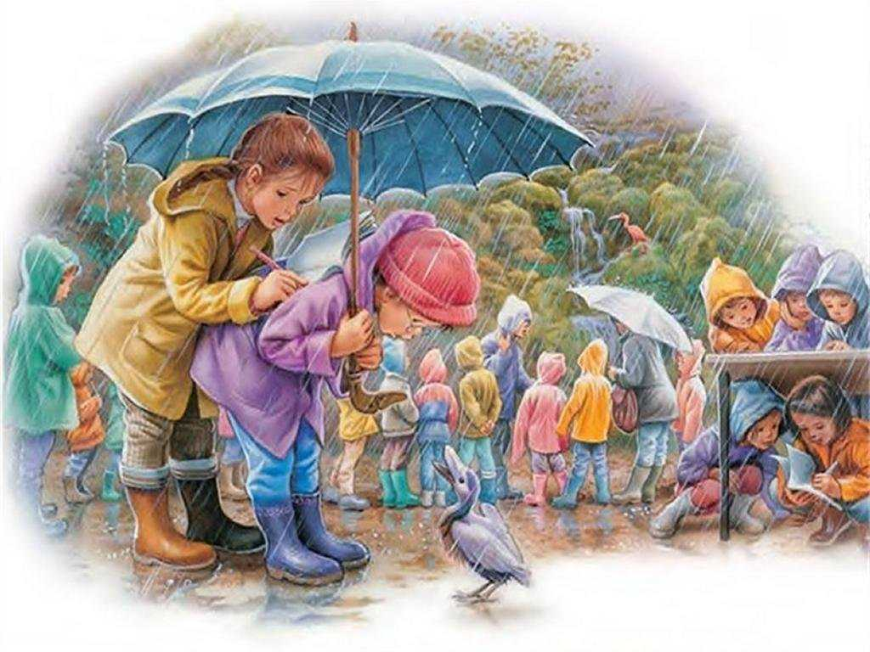

Present Continuous

S + to be + V-ing

am is are

Use the words:

Zoo

Is raining

A group of children

A boy and a girl

A bird

Under the table

Use the words:

Square

Children

Fountains

Father

Happy

Are playing

Wet through