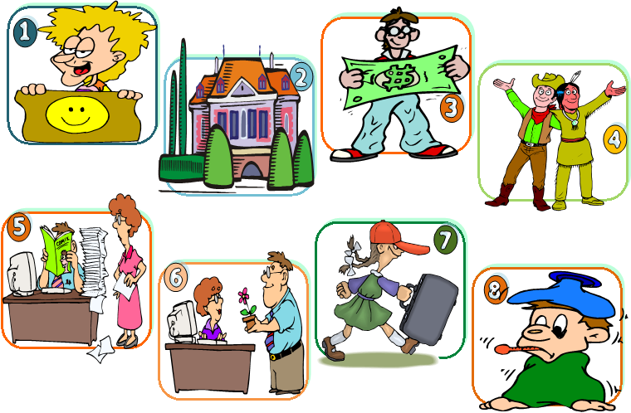

**A) Complete these predictions for the future**

You _____ (be) very happy

You ______

You ______ (make) a lot of good friends.

You _____(not live) in a mansion.

You ______ (get) your dream job.

You ____(not travel) around the world.

You ______(not have) any health problems.

Everybody ____(like) you at work.

**B) Complete the sentences with the suitable tense and form.**

a) I _________________ (phone) you when I arrive home.

b) _________________(not tell) anyone about your secret.

c) _________________ (you make) dinner for me?

d) I _________________ (not do ) your homework for you.

e) _________________ your mother / help) you later?

**3) Use the words to write questions and then give answers.**

a) he / come back / tomorrow/?

Will _______________________________? No, ______________.

b) she / have / more free time / in the future / ?

Will _______________________________? Yes, ______________.

c) it / rain / tomorrow/ ?

Will _______________________________? No, ______________.

d) you / join / our English club/?

Will _______________________________? Yes, ______________.

e) the students / win / the race/?

Will _______________________________? No, ______________.

f) we / have dance lessons/ at school/?

Will _______________________________? No, ______________.

